What’s The Difference Between FDD And TDD?
Jul 30, 2012 Lou Frenzel | Electronic Design

  - EMAIL
- inShare

Comments 0
Duplexing is the process of achieving two-way communications over a communications channel. It takes two forms: half duplex and full duplex (Fig. 1).

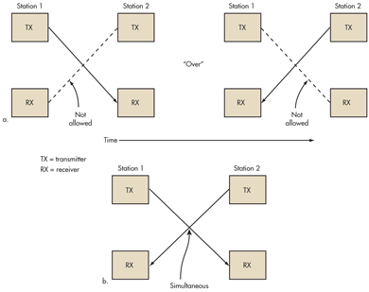
1. There are two modes of duplex operation: (a) half duplex and (b) full duplex.
In half duplex, the two communicating parties take turns transmitting over a shared channel. Two-way radios work this way. As one party talks, the other listens. Speaking parties often say “Over” to indicate that they’re finished and it’s time for the other party to speak. In networking, a single cable is shared as the two computers communicating take turns sending and receiving data.
Related
What’s The Difference Between GaAs And GaN RF Power Amplifiers?
What’s The Difference Between Satellite Radio And HD Radio?
What’s The Difference Between Bluetooth Low Energy And ANT?
What’s The Difference Between Cable And DSL Broadband Access?
Full duplex refers to simultaneous two-way communications. The two communicating stations can send and receive at the same time. Landline telephones and cell phones work this way. Some forms of networking permit simultaneous transmit and receive operations to occur. This is the more desirable form of duplexing, but it is more complex and expensive than half duplexing. There are two basic forms of full duplexing: frequency division duplex (FDD) and time division duplex (TDD) (see the table).

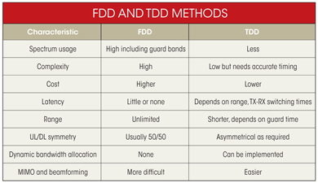

Table of Contents
- Frequency Division Duplex
- Time Division Duplex
- Application Examples
- Conclusion
- References

Frequency Division Duplex
FDD requires two separate communications channels. In networking, there are two cables. Full-duplex Ethernet uses two twisted pairs inside the CAT5 cable for simultaneous send and receive operations.
Wireless systems need two separate frequency bands or channels (Fig. 2). A sufficient amount of guard band separates the two bands so the transmitter and receiver don’t interfere with one another. Good filtering or duplexers and possibly shielding are a must to ensure the transmitter does not desensitize the adjacent receiver.

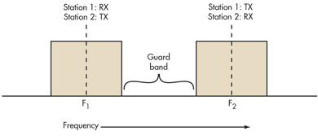
2. FDD requires two symmetrical segments of spectrum for the uplink and downlink channels.
In a cell phone with a transmitter and receiver operating simultaneously within such close proximity, the receiver must filter out as much of the transmitter signal as possible. The greater the spectrum separation, the more effective the filters.
FDD uses lots of frequency spectrum, though, generally at least twice the spectrum needed by TDD. In addition, there must be adequate spectrum separation between the transmit and receive channels. These so-called guard bands aren’t useable, so they’re wasteful. Given the scarcity and expense of spectrum, these are real disadvantages.
However, FDD is very widely used in cellular telephone systems, such as the widely used GSM system. In some systems the 25-MHz band from 869 to 894 MHz is used as the downlink (DL) spectrum from the cell site tower to the handset, and the 25-MHz band from 824 to 849 MHz is used as the uplink (UL) spectrum from the handset to cell site.
Another disadvantage with FDD is the difficulty of using special antenna techniques like multiple-input multiple-output (MIMO) and beamforming. These technologies are a core part of the new Long-Term Evolution (LTE) 4G cell phone strategies for increasing data rates. It is difficult to make antenna bandwidths broad enough to cover both sets of spectrum. More complex dynamic tuning circuitry is required.
FDD also works on a cable where transmit and receive channels are given different parts of the cable spectrum, as in cable TV systems. Again, filters are used to keep the channels separate.

Time Division Duplex
TDD uses a single frequency band for both transmit and receive. Then it shares that band by assigning alternating time slots to transmit and receive operations (Fig. 3). The information to be transmitted—whether it’s voice, video, or computer data—is in serial binary format. Each time slot may be 1 byte long or could be a frame of multiple bytes.

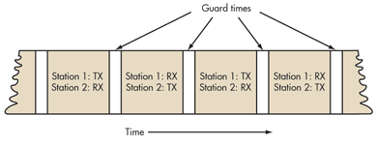
3. TDD alternates the transmission and reception of station data over time. Time slots may be variable in length.
Because of the high-speed nature of the data, the communicating parties cannot tell that the transmissions are intermittent. The transmissions are concurrent rather than simultaneous. For digital voice converted back to analog, no one can tell it isn’t full duplex.
In some TDD systems, the alternating time slots are of the same duration or have equal DL and UL times. However, the system doesn’t have to be 50/50 symmetrical. The system can be asymmetrical as required.
For instance, in Internet access, download times are usually much longer than upload times so more or fewer frame time slots are assigned as needed. Some TDD formats offer dynamic bandwidth allocation where time-slot numbers or durations are changed on the fly as required.
The real advantage of TDD is that it only needs a single channel of frequency spectrum. Furthermore, no spectrum-wasteful guard bands or channel separations are needed. The downside is that successful implementation of TDD needs a very precise timing and synchronization system at both the transmitter and receiver to make sure time slots don’t overlap or otherwise interfere with one another.
Timing is often synched to precise GPS-derived atomic clock standards. Guard times are also needed between time slots to prevent overlap. This time is generally equal to the send-receive turnaround time (transmit-receive switching time) and any transmission delays (latency) over the communications path.

Application Examples
Most cell-phone systems use FDD. The newer LTE and 4G systems use FDD. Cable TV systems are fully FDD.
Most wireless data transmissions are TDD. WiMAX and Wi-Fi use TDD. So does Bluetooth when piconets are deployed. ZigBee is TDD. Most digital cordless telephones use TDD. Because of the spectrum shortage and expense, TDD is also being adopted in some cellular systems, such as China’s TD-SCDMA and TD-LTE systems. Other TD-LTE cellular systems are expected to be deployed where spectrum shortages occur.

Conclusion
TDD appears to be the better overall choice, but FDD is far more widely implemented because of prior frequency spectrum assignments and earlier technologies. FDD will continue to dominate the cellular business for now. Yet as spectrum becomes more costly and scarce, TDD will become more widely adopted as spectrum is reallocated and repurposed.

References
- Moonblink
- Netkrom Technologies
- Radio-Electronics
- Frenzel, L.E., Principles of Electronics Communications Systems, 3rd edition, McGraw Hill, 2008, http://www.amazon.com/Principles-Electronic-Communication-published-Education/dp/B008DMCPU0.

